MRF-Application Gateway Implementation On Application

Traffic Flow Diagram.

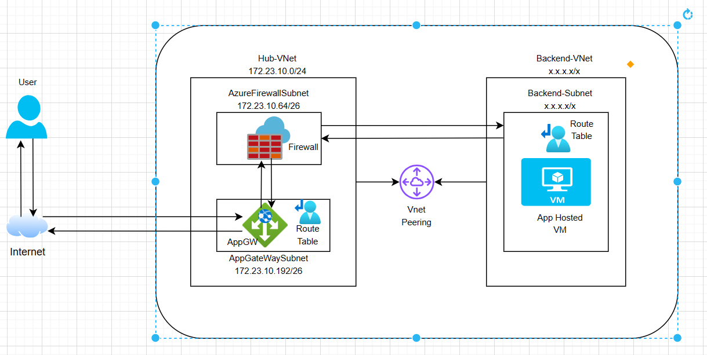

Steps to Configure:
- Create Backend Pool
- Create Health Probe
- Create Backend Settings and attach health probe
- Create Listener
- Create Rule
- Create WAF Policy and Assign at Listener Level
- Allow inbound and outbound traffic to and from Application Gateway - AppVM at the Firewall Network Rule.
- Check for Forward Route and Create UDR at Application Gateway Subnet Level to forward the traffic to Azure Firewall if missing.
- Check for reverse route and create UDR at AppVM subnet level to send the traffic to next hop Azure Firewall.

Step1: Create Backend Pool
- Open App Gateway and click on Backend Pool and click Add.
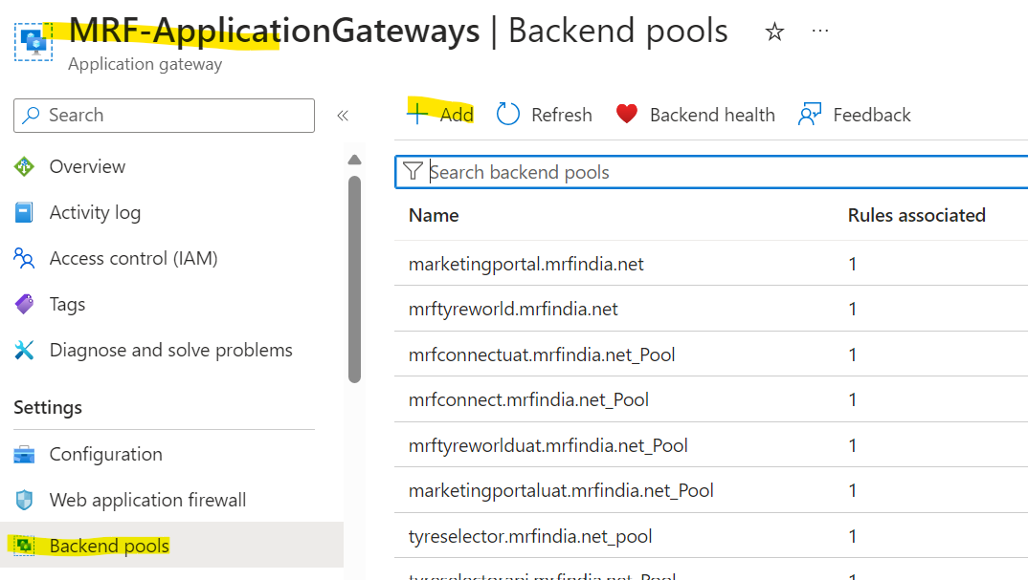
- Provide the name and target like below and click on add. Naming convention will be fqdn_Pool.

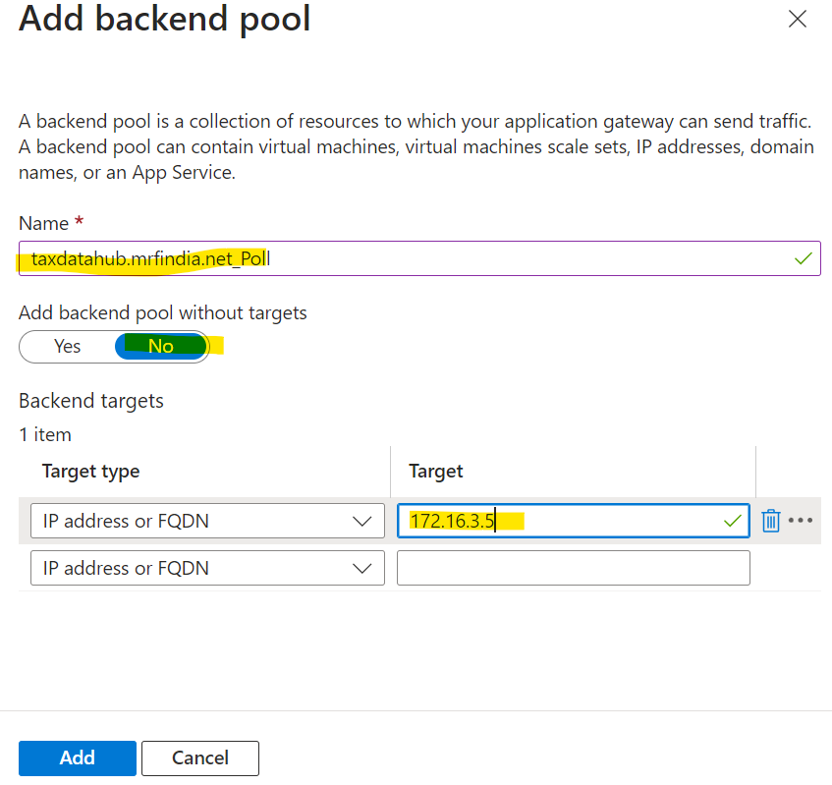
Step2: Create Health Probe
- Click on Health Probe and click on Add.
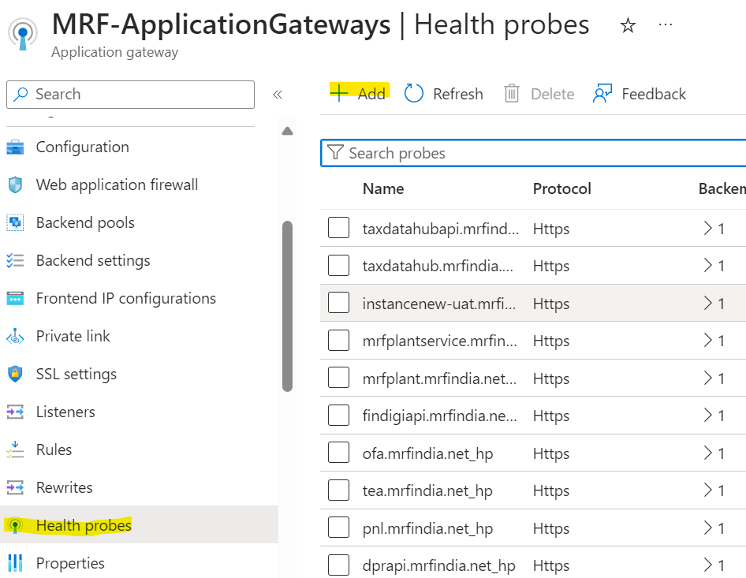
- Mention the name, port, hostname details like below and click on add. Naming convention will be FQDN_hp.
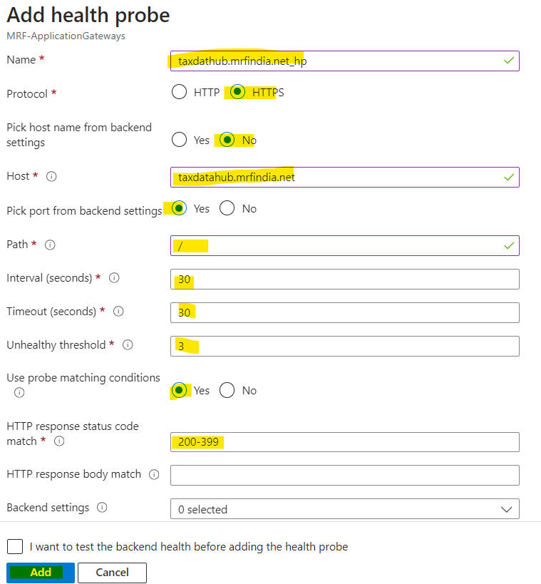
Step3: Create Backend Settings and Attach Health Probe
- Click on Backend settings and click on Add.
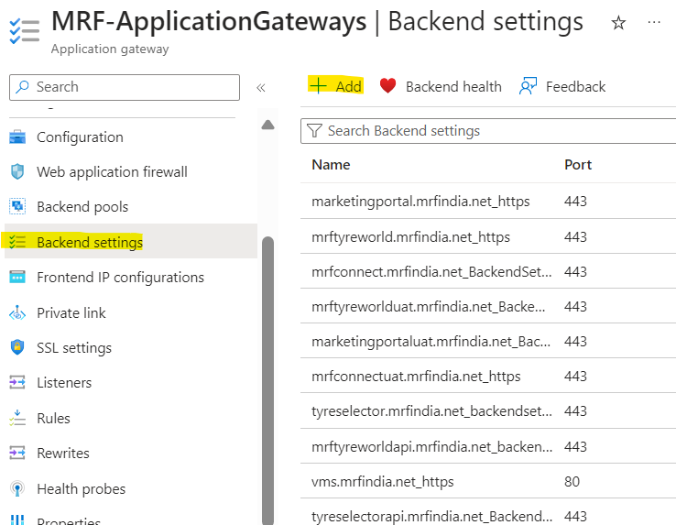
- Provide the details like below and add the health probe and click on Save. Naming convention will be FQDN_https.
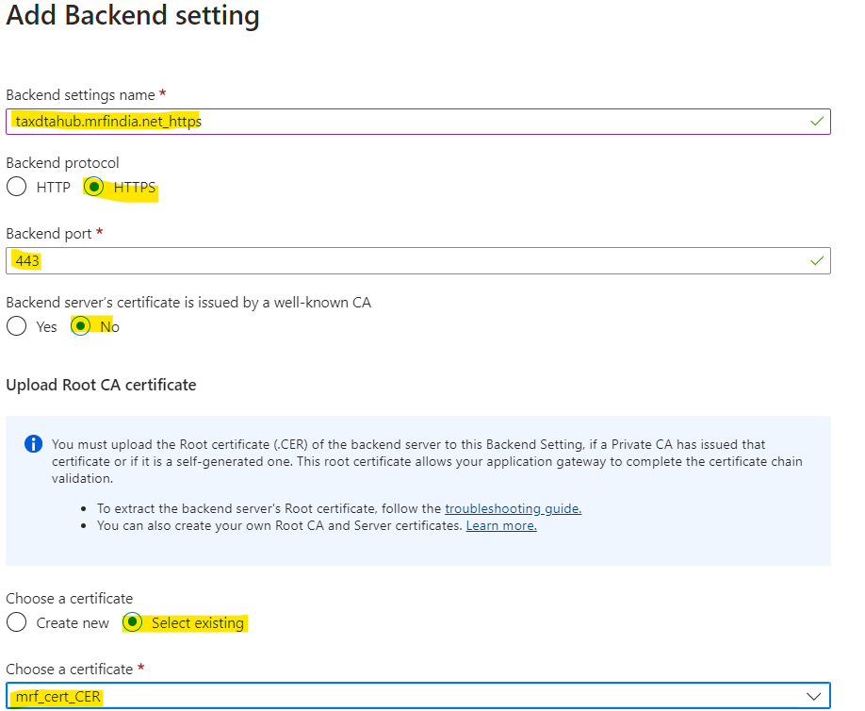
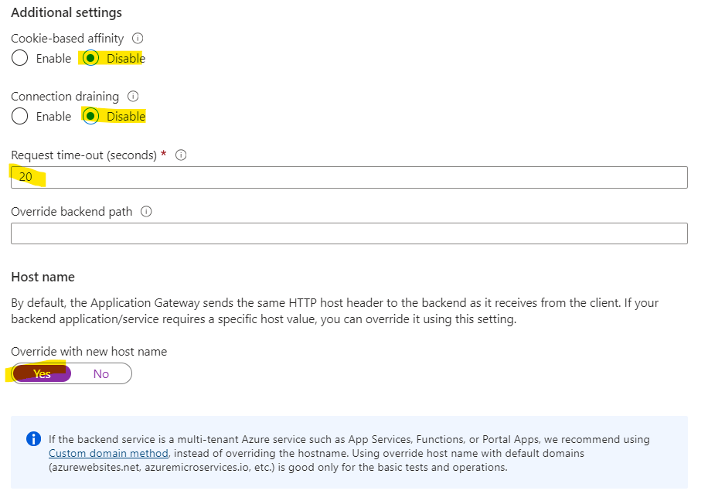
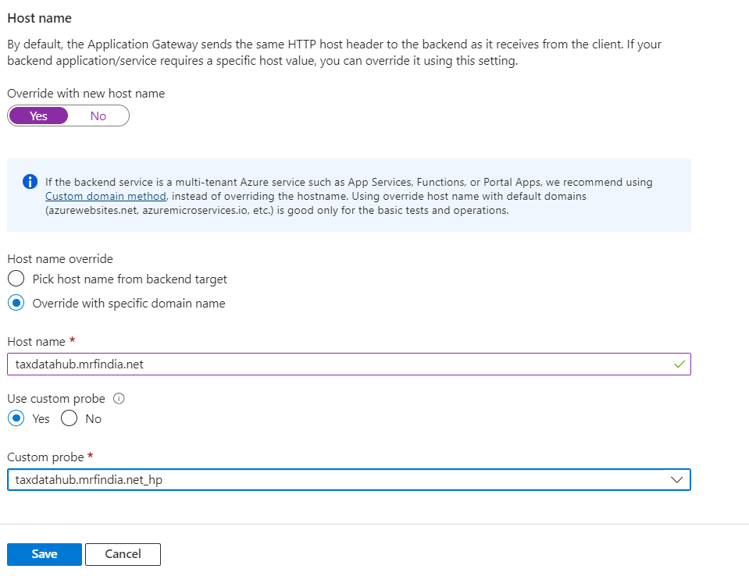
Step4: Create Listener
- Click on Listeners and click on Add Listener.
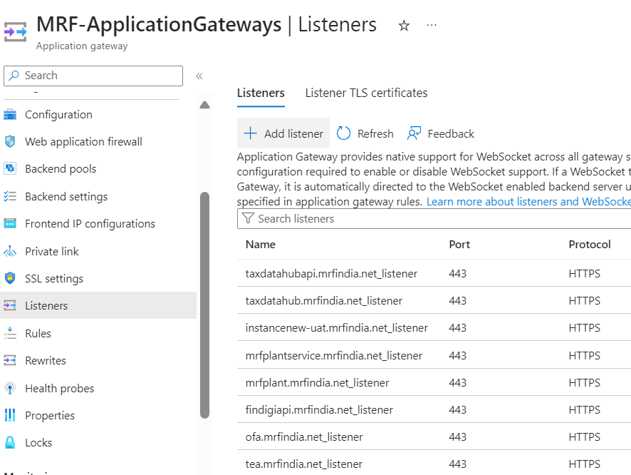
- Provide the details like below and click on add. Naming convention will be FQDN_listener.
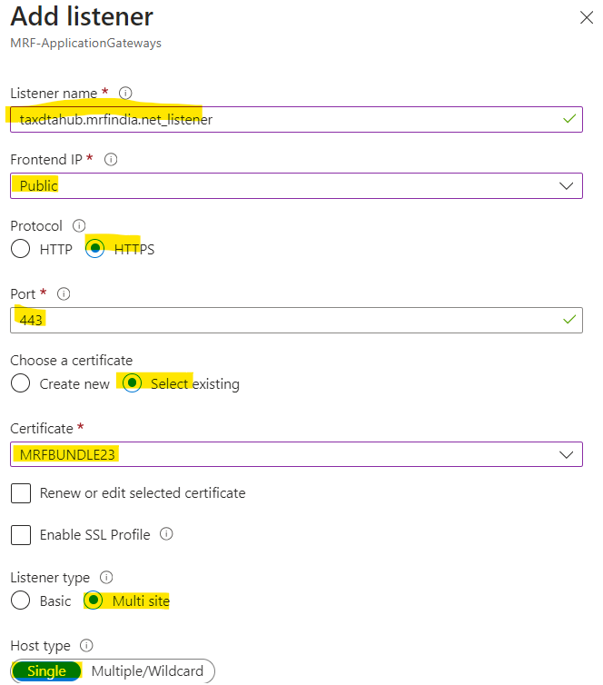
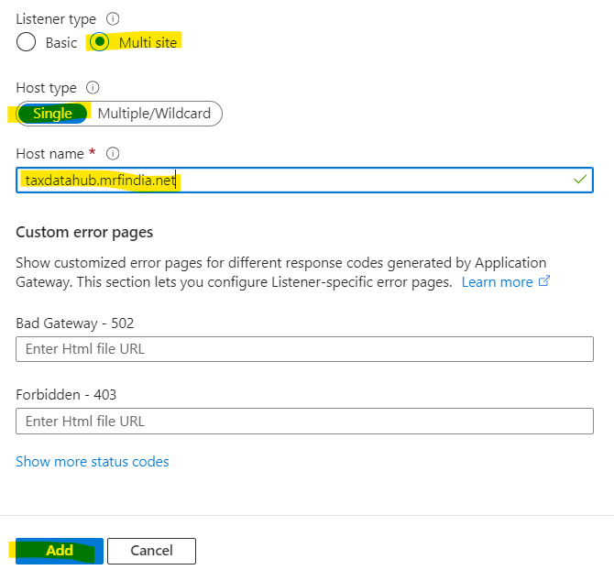
Step5: Add Rules
- Click on Rules and select Routing Rules.
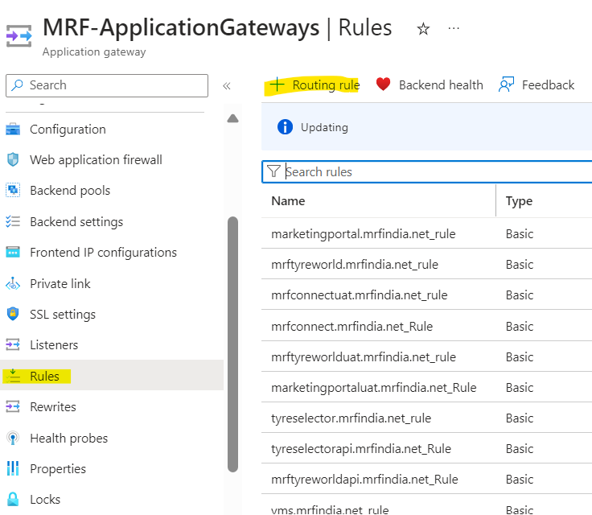
- Provide the Name, Priority, listener, Backend Targets and Backend Settings and click on Save.
Note: Priority and Name should be Unique.
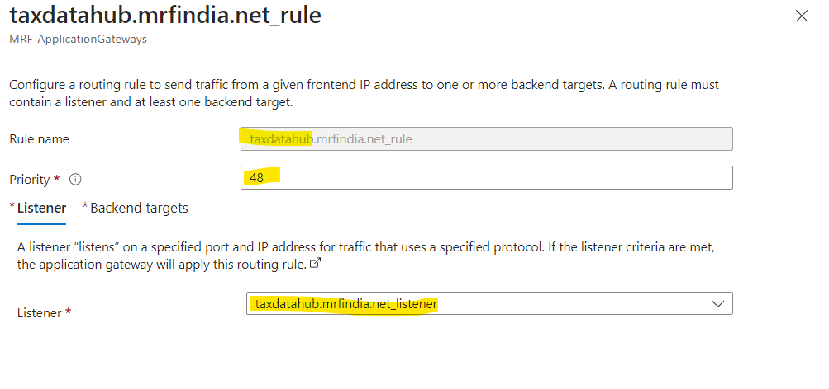
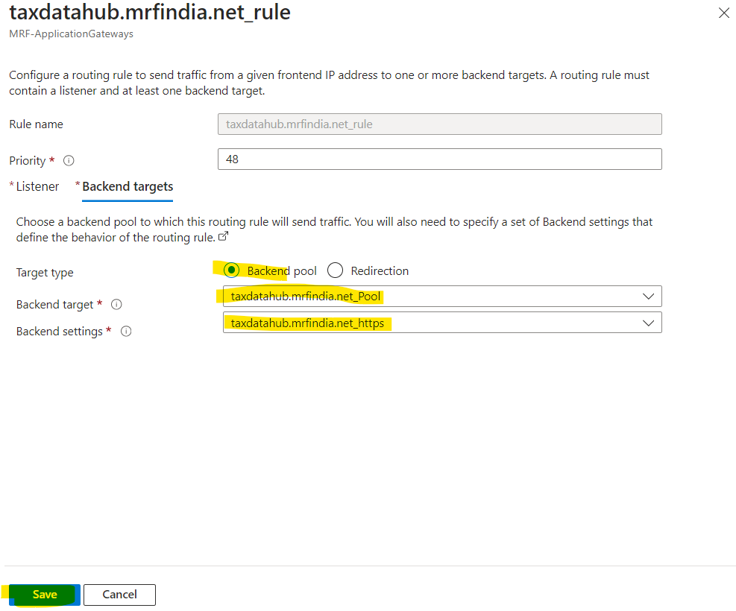
Step6: Create WAF Policy and Assign at Listener Level
- Open Web Application Firewall Policies(WAF) and Click Create.
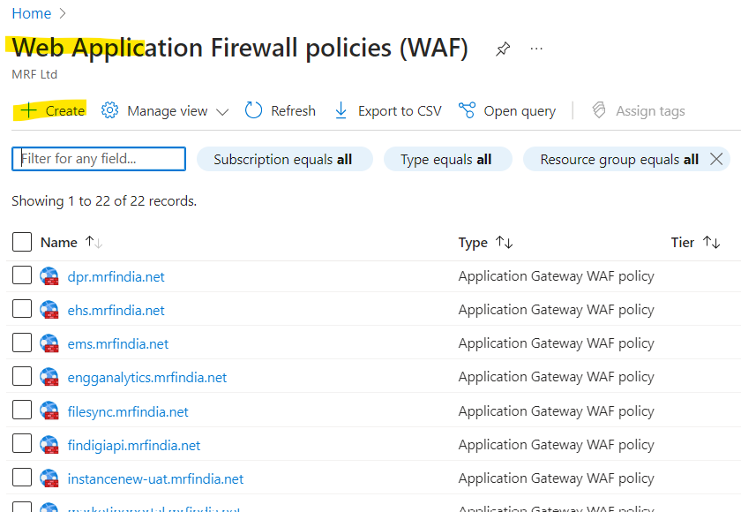
- Fill the details like below and click on review+create.
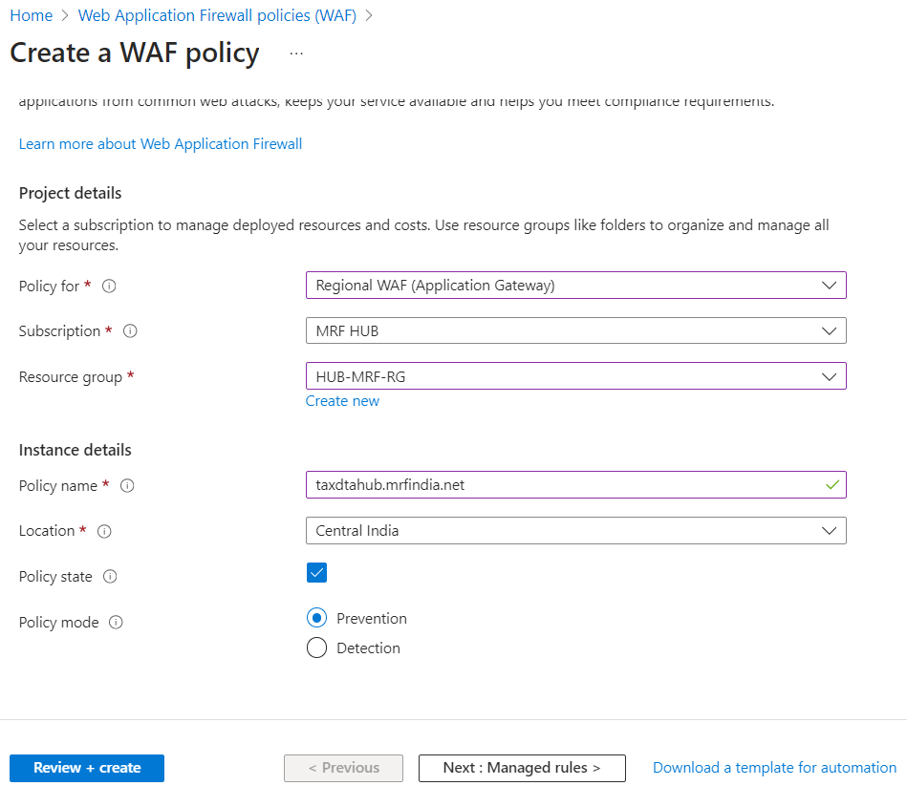

- Now Open any of the existing WAF Policy and click on custom rules. Select the Rule and click on Copy to another policy.
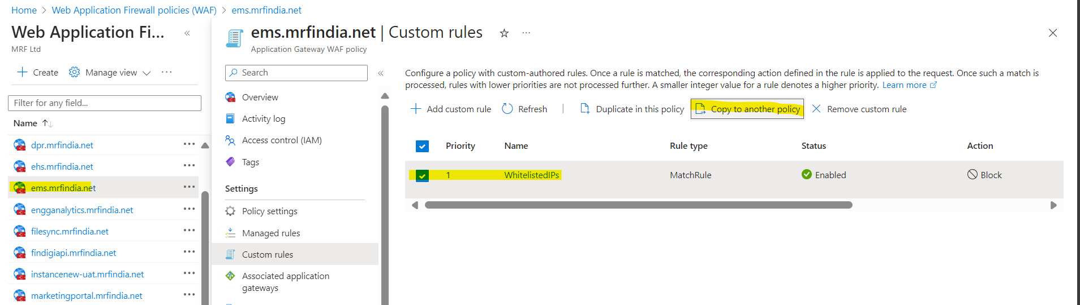

- Select the WAF Policy from the drop down menu and mention the Priority and click on copy.
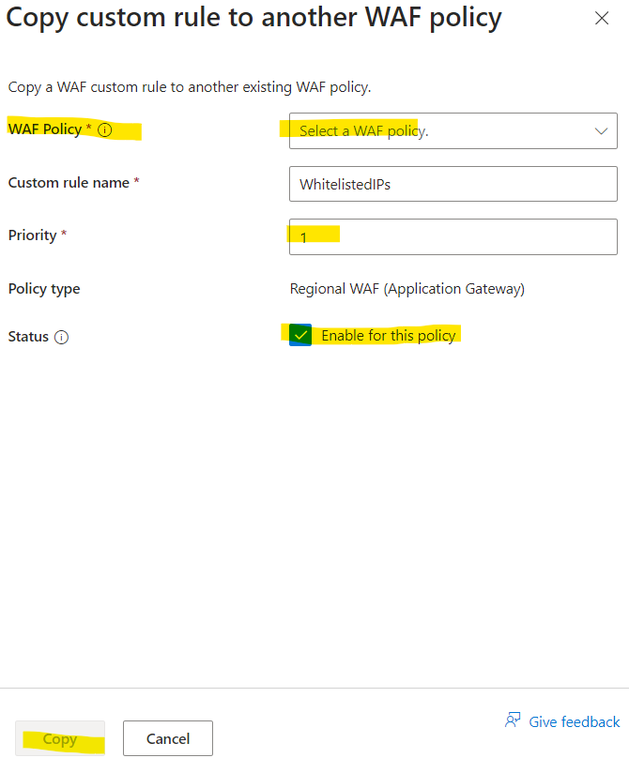
- Click on the policy created and select Associated Application Gateways option and click on Add association and select HTTP listener.
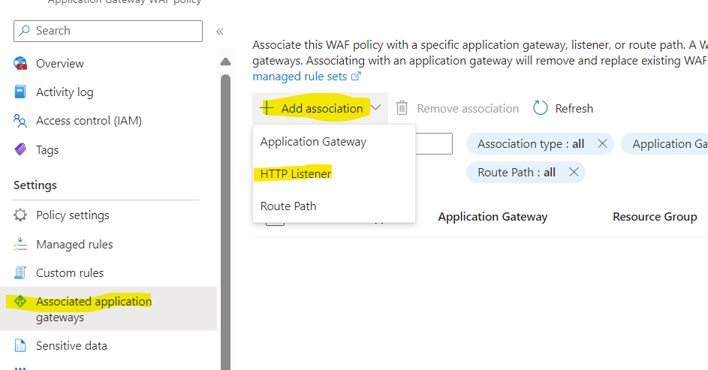
- Select the Application Gateway and Listeners from the drop down menu and click on Add.
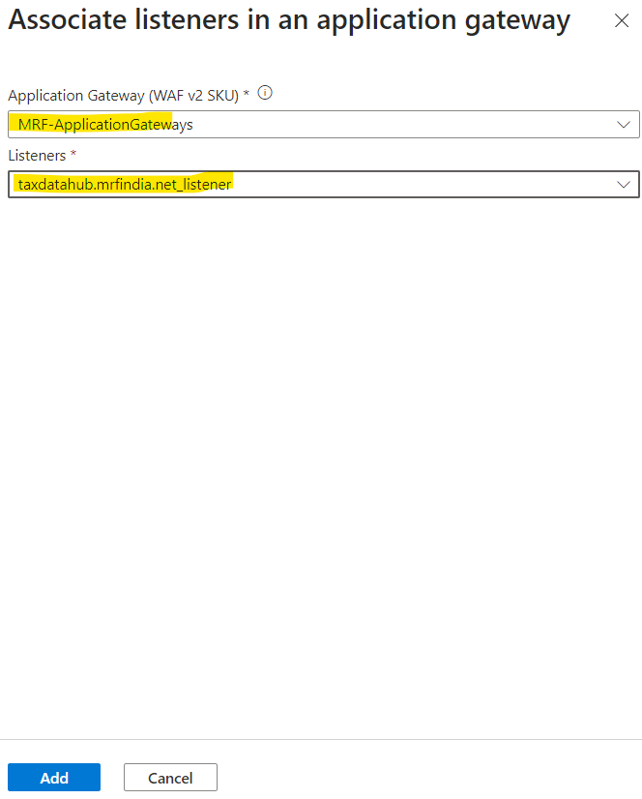
Step7: Allow inbound and outbound traffic to and from Application Gateway - AppVM at the Firewall Network Rule.
- Open Firewall and click on PremiumPolicy.
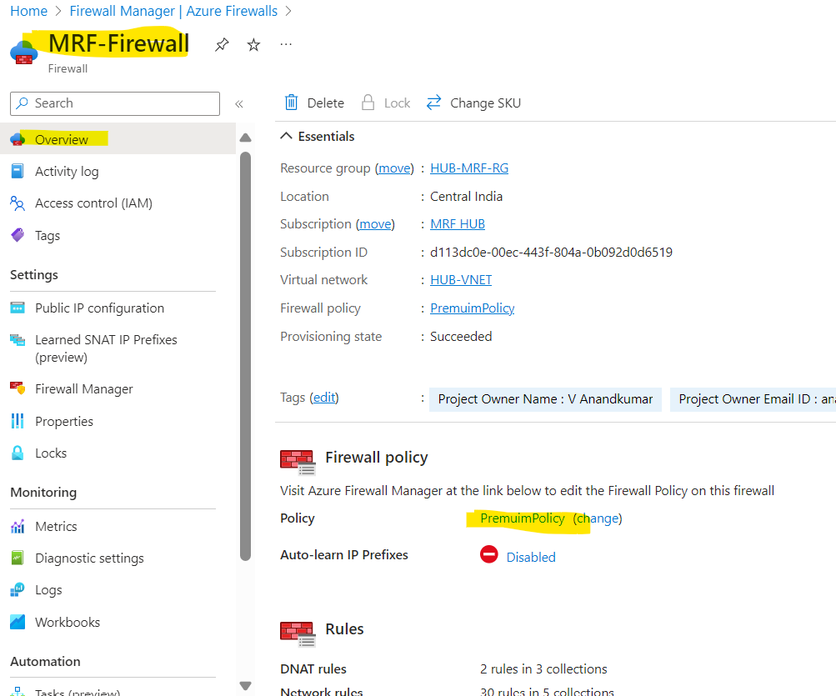
- Click on Network Rules and in search provide the IP of AppVM, if found rule for the given IP then move to next page else proceed for adding the IP in rule for forwarding the traffic to the VM.
- For adding the IP in the rule, select AppGW-to-APPVms-Communication rule and click on edit and add the IP in Destination IP Addresses and click Save.
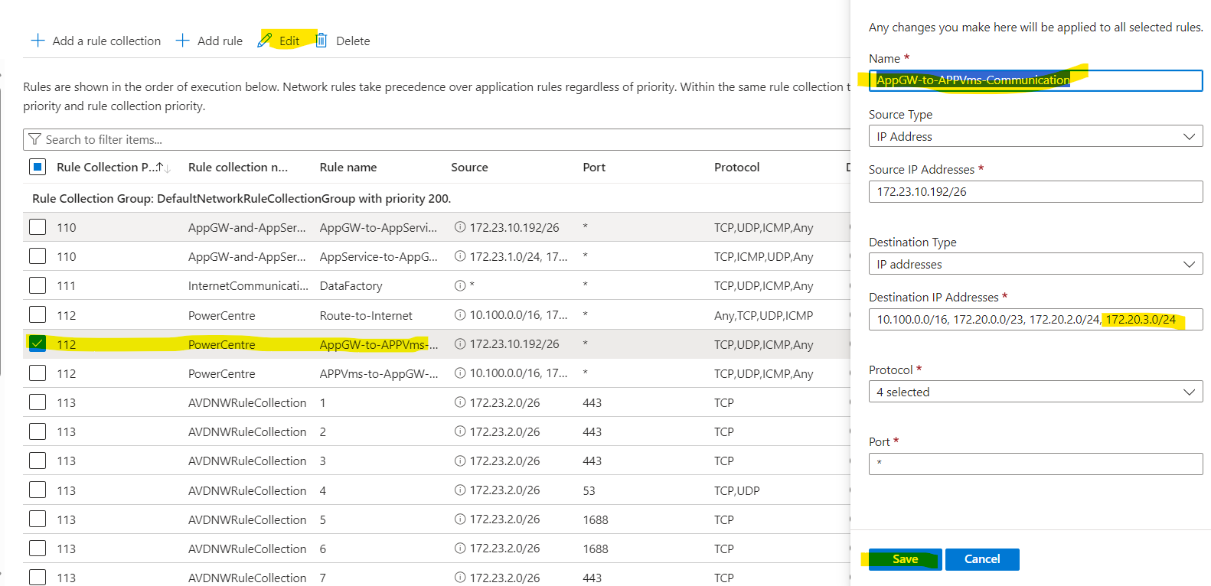
- Click on Network Rules and in search provide the IP of AppVM, if found rule for the given IP then move to next page else proceed for adding the IP in rule for forwarding the traffic to the Application Gateway.
- For adding the IP in the rule, select APPVms-to-AppGW-Communication rule and click on edit and add the IP in Source IP Addresses and click Save.
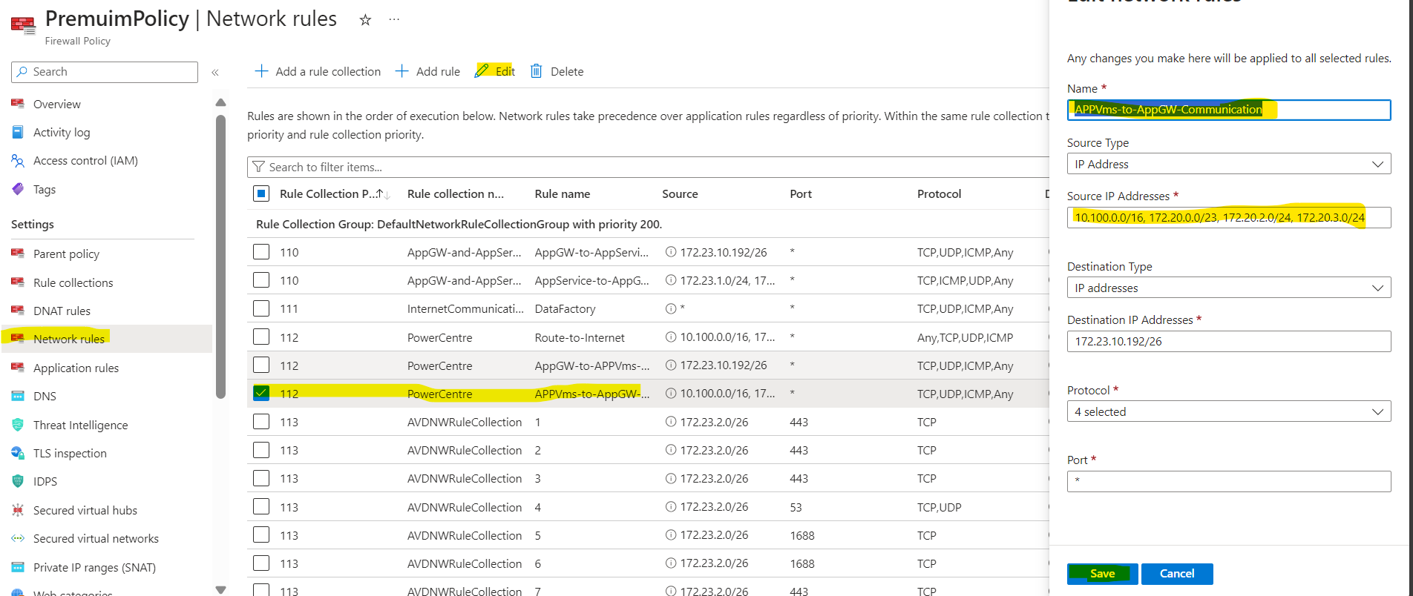

Step8: Check for Forward Route and Create UDR at Application Gateway Subnet Level to forward the traffic to Azure Firewall if missing.
- Open Hub-Vnet and click on subnets and select AzureAppGatewaySubnet and look for the Route Table associated.
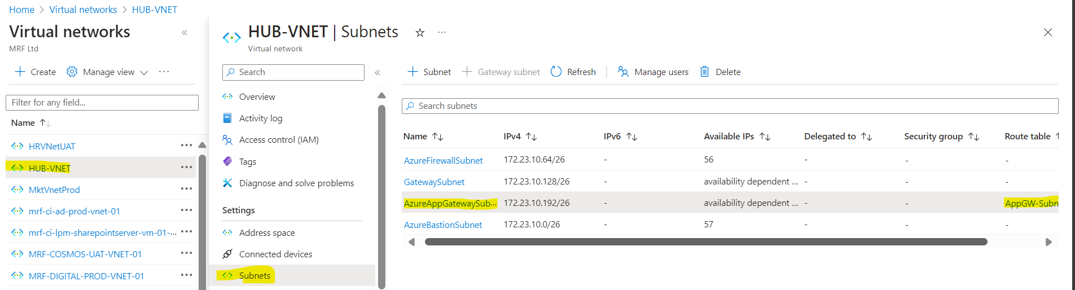
- Open the Route Table associated with it click on routes and provide the subnet address space in search box, fi found then move to next step else Add new rule.
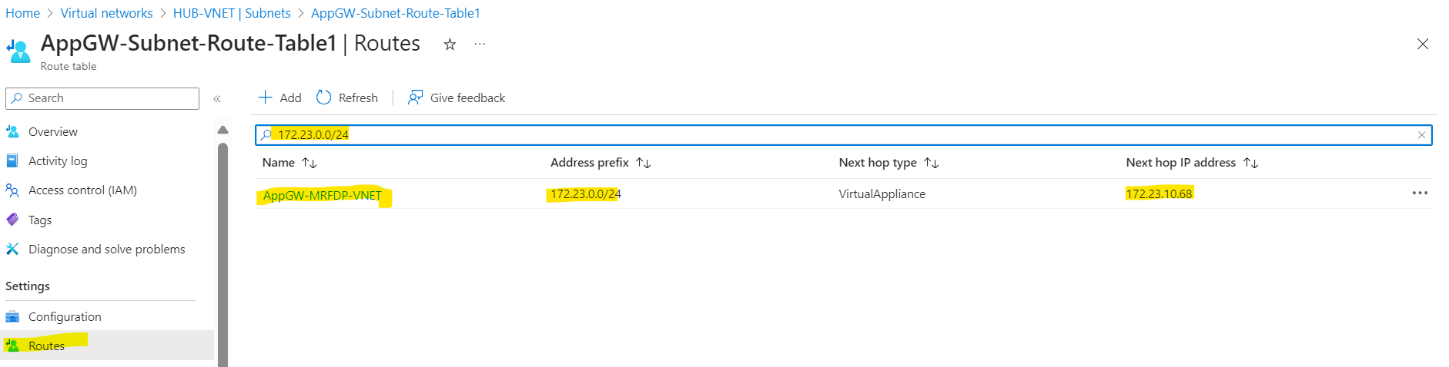
- If not found then Click on Add and provide the details like below. In Destination IP address field enter the Subnet address space of VM and click on Add.
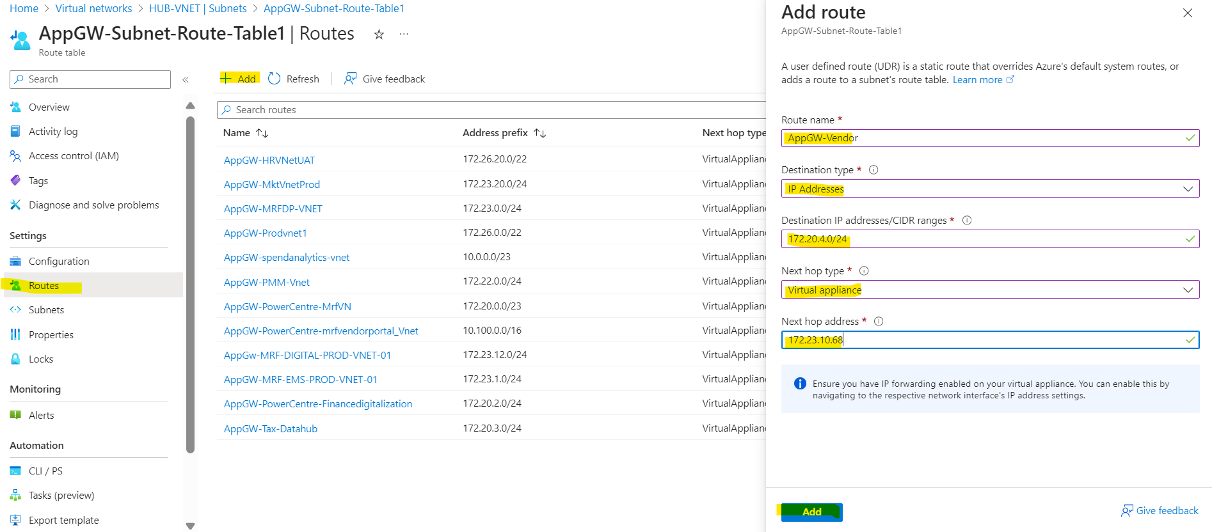
Step9: Check for reverse route and create UDR at AppVM subnet level to send the traffic to next hop Azure Firewall.
- Goto the AppVM subnet and look for the subnet associated with it.

- Open the Route Table associated with it and click on routes and provide the AzureAppGatewaysubnet address space in search box, if found then leave else Add new rule.
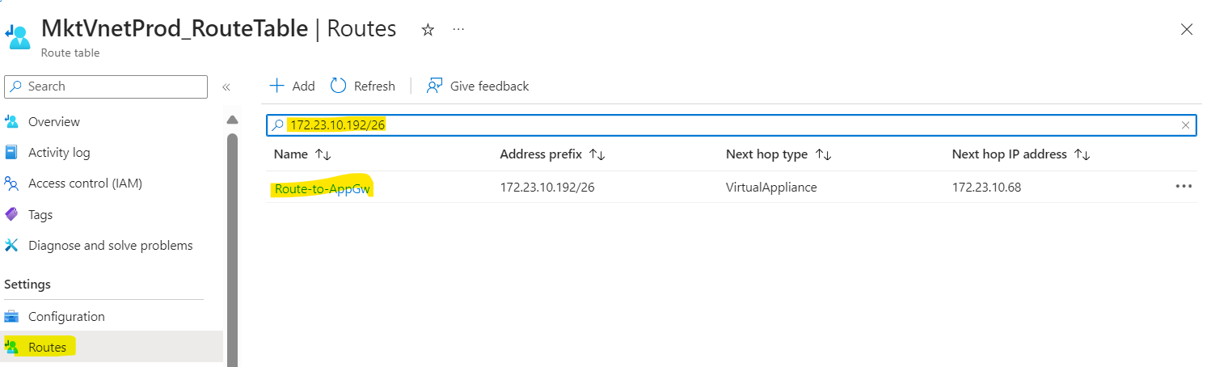
- If not found then Click on Add and provide the details like below. In Destination IP address field enter the AzureAppGatewaySubnet address space and click on Add.
